**Sentiment Analysis of Celebrity Impact in the Entertainment Sector**

Pooja Joshi & E.Code [E25007]

# Overview :

# This report covers the comprehensive process of analyzing audience sentiment related to celebrity-driven entertainment content. Key tasks involved performing sentiment analysis on a dataset of mock reviews, examining sentiment trends over time, correlating sentiment with performance metrics like popularity and attendance, and implementing advanced analysis techniques.

# Objective:

● To analyze sentiment in audience reviews and understand its impact on entertainment metrics.  
● To examine how major events associated with celebrities influence public sentiment.

# Assigned Task(s) :

● Conduct sentiment analysis using VADER on mock reviews.  
● Analyze sentiment trends over time and correlate them with metrics such as popularity and attendance.  
● Conduct advanced analysis for sentiment by title and event-based trend annotations.  
● Visualize sentiment distribution and trends effectively.

# Task Details :

**Task 1: Sentiment Analysis on Audience Reviews**

* **Status:** Completed
* **Details:** Performed sentiment analysis using VADER on a dataset of mock reviews, categorizing sentiments as Positive, Neutral, and Negative. The average sentiment per review was calculated and visualized.

**Task 2: Time-Based Sentiment Analysis**

* **Status:** Completed
* **Details:** Analyzed sentiment trends by plotting daily averages of the sentiment scores over time to observe shifts in public opinion.

**Task 3: Advanced Analysis Options**

* **Status:** Completed
* **Details:** Conducted sentiment analysis by title to see which content had the highest or lowest sentiment. Added event-based annotations to the time-based trend analysis to identify any impact of key events on audience sentiment.

**Task 4: Visualization**

* **Status:** Completed
* **Details:** Created visualizations for sentiment distribution across positive, neutral, and negative categories. Developed line charts to illustrate daily sentiment trends and bar charts for sentiment by title.

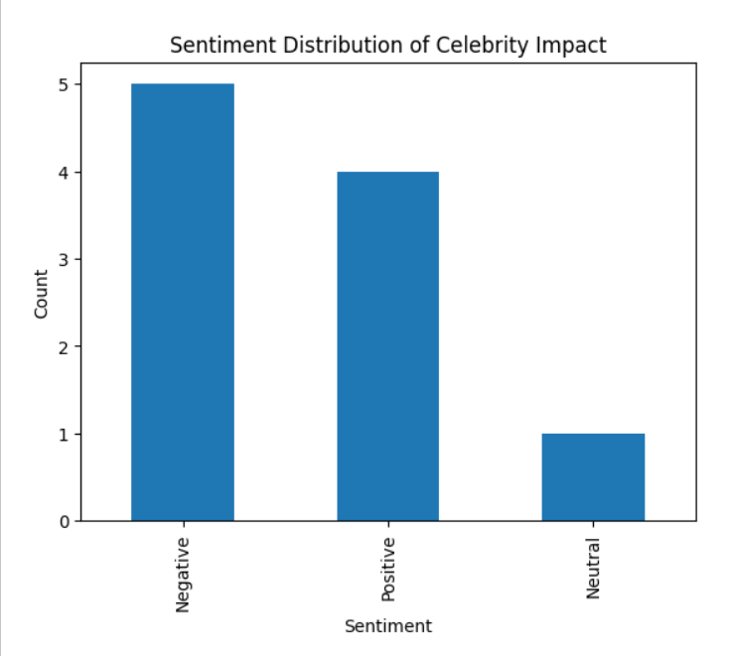

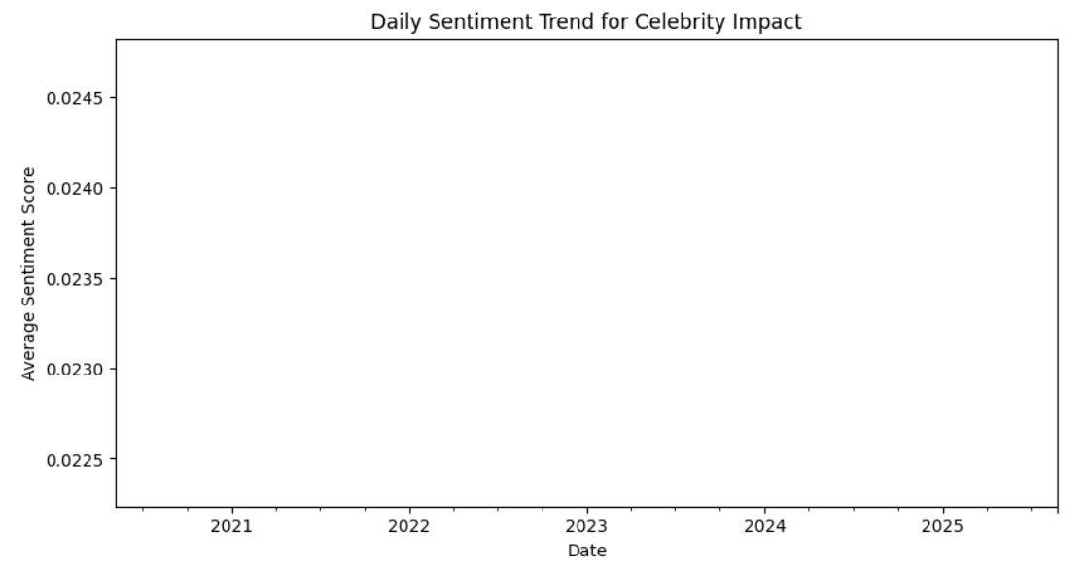

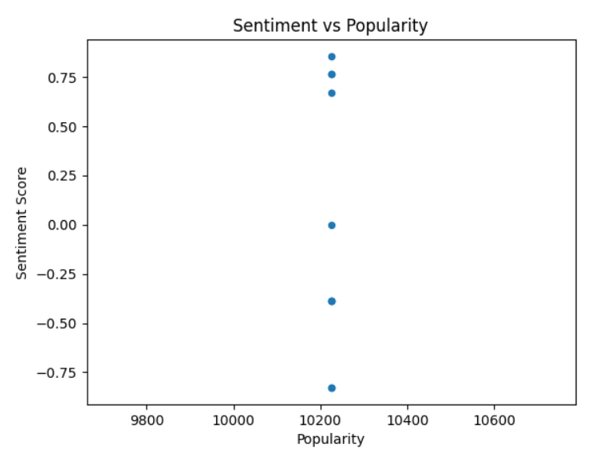

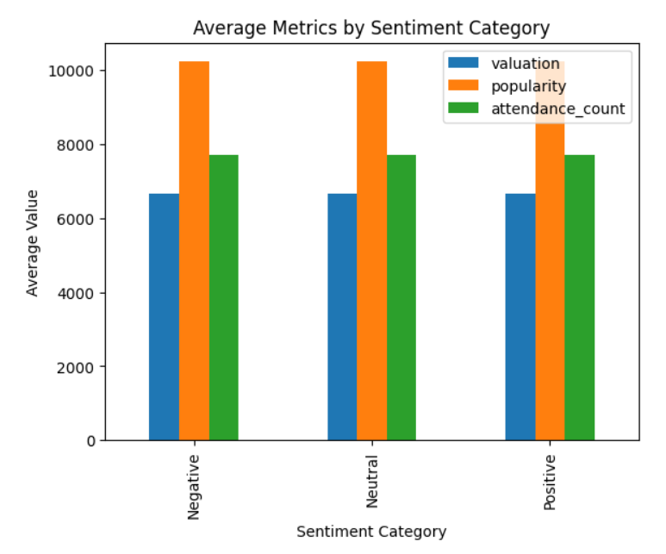

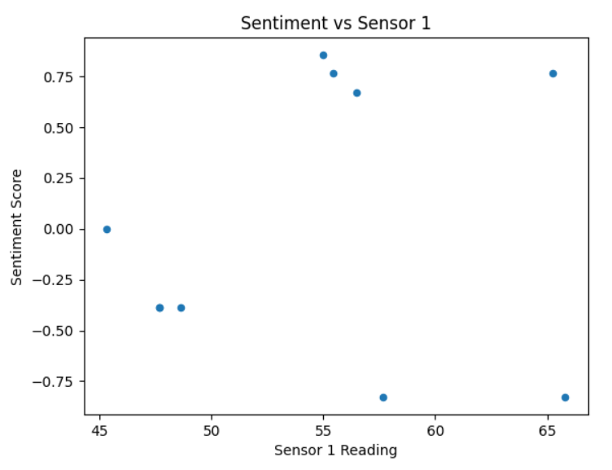

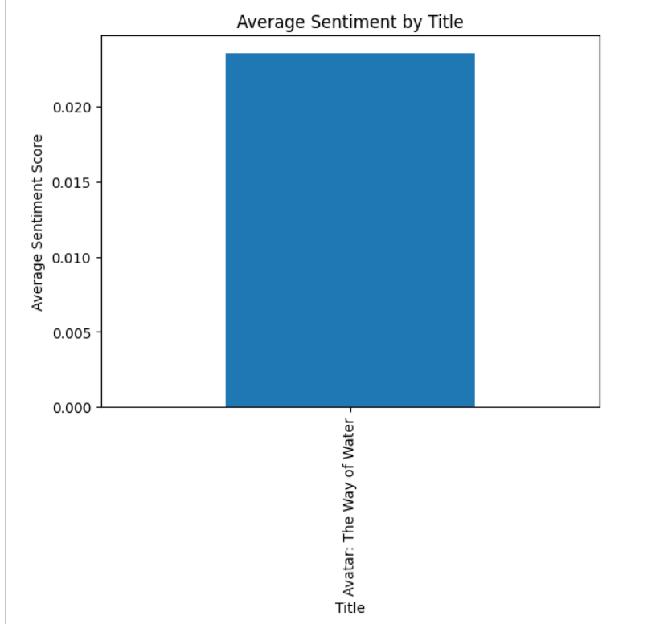

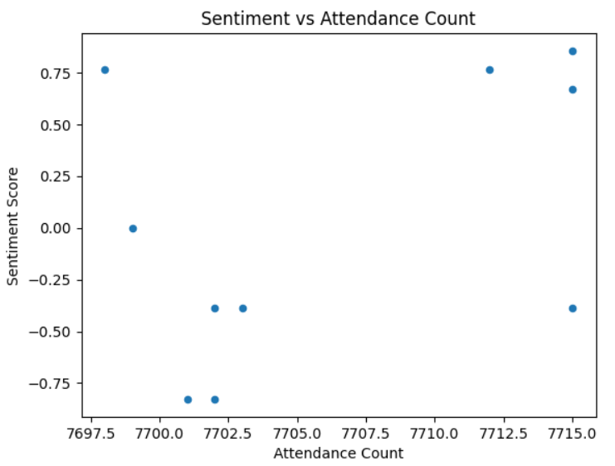

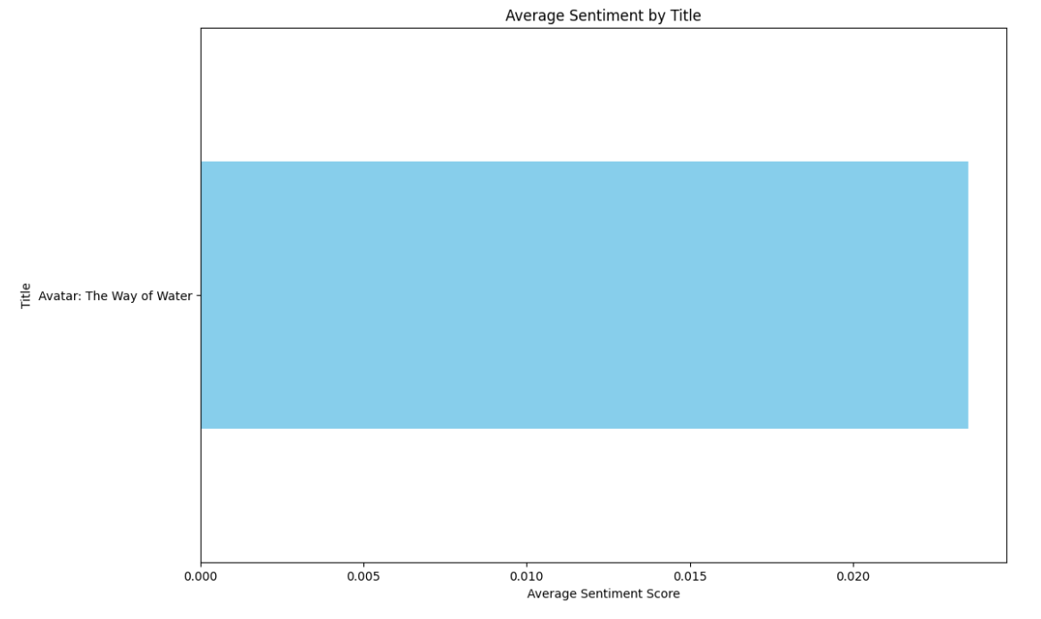

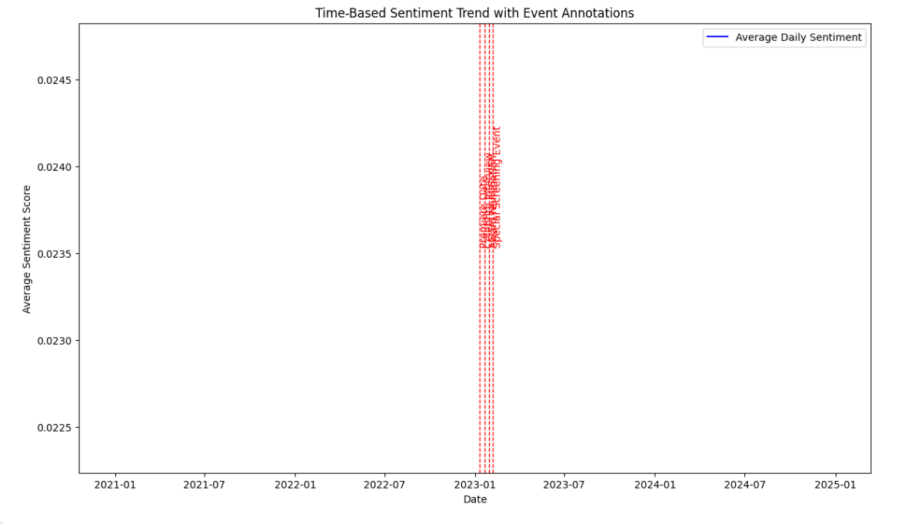

**Progress :**

* **Accomplishments:**

● Successfully implemented VADER-based sentiment analysis.  
● Created visualizations of daily sentiment trends, allowing for clear insights into shifts in audience opinion over time.  
● Developed advanced analyses to correlate sentiment with titles and highlight significant events, contributing to a deeper understanding of celebrity impact.

* **Metrics:**  
  ● Sentiment Distribution: Proportion of Positive, Neutral, and Negative reviews.  
  ● Average Sentiment Scores per Title: Provides insights into which content generates the most favorable or unfavorable response.  
  ● Daily Sentiment Trends with Event Annotations: Identified sentiment shifts around major events.

# Challenges and Solutions :

* **Challenges Faced:**  
   Ensuring accuracy in sentiment categorization for nuanced reviews.  
   Aligning event dates with sentiment shifts to observe potential correlations.
* **Solutions Implemented:**  
   Utilized VADER sentiment analysis for consistency and reliability in scoring.  
   Added event annotations directly on trend plots, making it easier to visually identify patterns associated with major events.

**Next Steps :**

* **Upcoming Tasks:**
* Perform a comparative analysis of celebrity impact across different content types (e.g., movies, shows).  
   Extend sentiment analysis to social media comments for a broader sentiment assessment.
* **Goals:**  
  Refine the model for sentiment scoring based on additional datasets.  
   Implement clustering techniques to categorize reviews by specific audience segments.

# Conclusion :

### Summary: This report detailed the steps and analyses for understanding audience sentiment related to celebrity-driven content, incorporating basic sentiment analysis and advanced techniques like title-based sentiment scoring and event annotations. This analysis provides valuable insights into how celebrities influence audience reception, which can be used to guide marketing and content development strategies.

# **Acknowledgments**: Thank the audience for their time and attention.